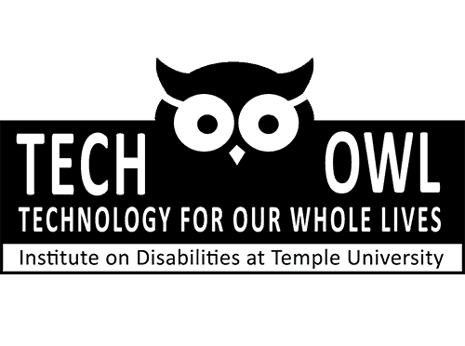

Join Assistive Technology Champions!

Begins October 2023

Who are we? | TechOWL (Technology for Our Whole Lives)  Main ofﬁce #: 800-204-7428 Izzy's phone Ext. 3053
Who can join? | Young adults with developmental/intellectual disabilities in PA. All AT Champions will receive a stipend.
Curious about AT? Want to build your own devices? Are you looking for your own AT? Want to meet fellow adults with disabilities? AT Champs will work with TechOWL staff to create posts about assistive technology. AT Champions will explore AT topics in workshops and complete monthly activities. They will learn about how AT can play a role in their daily lives. AT Champions will spread the word about AT in their communities!
Monthly Online meetings will be on Wednesday afternoons on Zoom from October 2023 to March 2024.
Please ﬁll out the application if you are interested in joining this fun and exciting new program!
Please email izzy.kaufman@temple.edu, Alanna.raffel@temple.edu, or Thomas.diagostino@temple.edu for application assistance.
Important Dates and Topics
Disability Justice and Pride Jan 3rd: Workshop 3:00-4:30 Jan17th: Check-in 3:00-3:30
How to ﬁnd funding for your AT Feb 7th: Workshop 3:00-4:30 Feb21st: Check-in 3:00-3:30 Moving Forward and Wrap up March 6th: Workshop 3:00-4:30
March 20th: Check in 3:00-3:30

Intro and Social Media Tips/Skill Building

Oct 4th: Workshop 3:00-4:30
Oct 18th: Check in 3:00-3:30
AT Essentials: Explore the world of AT!

Nov 1st: Workshop 3:00-4:30
Nov 15th: Check-in 3:00-3:30
Fabrication: Do it yourself AT!
Dec 6th: Workshop 3:00-4:30

Individual check-ins by appointment

