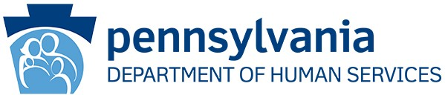

Social Security Administration (SSA) Announces 2024 Cost of Living Adjustment (COLA)
ODP Announcement 23-103

AUDIENCE:

- Residential Habilitation or Life Sharing providers who collect room and board fees from individuals enrolled in the Consolidated, Community Living, or Adult Autism Waivers
- Providers of base-funded Residential Habilitation or Life Sharing services
- Other Interested Parties

PURPOSE:

To provide notice that the Federal Supplemental Security Income (SSI) payment will increase beginning January 2024.

DISCUSSION:

SSI is a federal program that provides benefits to adults and children who meet the SSA’s requirements for disability, income, and resources. This income benefit is designed to help qualified individuals meet basic needs for food, clothing, and shelter.
Periodically, a COLA affects the maximum monthly allotment. Effective January 2024, the SSA increased the SSI allotment by 3.2 percent to reflect an increase in the cost of living. This raises the maximum monthly income to $943 for an eligible individual,
$1,415 for an eligible individual with an eligible spouse, and $472 for an essential person.
There is no anticipated increase in the State Supplementary Payment (SSP) for 2024.

Office of Developmental Programs Announcement 23-103 Page 1 of 2 Publication Date: 12/18/2023

To account for the new COLA, room and board agreements should be reviewed to determine appropriate adjustment.¹ The Room and Board Residency Agreement § 6100.687 (DP 1077) is found on MyODP.org at https://home.myodp.org/resources/autism-resources/forms/ or by following this path: Resources> Forms.
This announcement obsoletes Announcement 22-127, Social Security Administration Announces 2023 Cost of Living Adjustment. For more specific information regarding SSI and the COLA, please review the U.S. Social Security Administration website or visit: SSI Federal Payment Amounts for 2024 (ssa.gov).

If you have any questions, please reach out to your ODP Regional Office.

1 Further information will be released in The Room and Board Bulletin that will be forthcoming. Office of Developmental Programs Announcement 23-103 Page 2 of 2
Publication Date: 12/18/2023

